

**GENERATIVE AI: APPLICATIONS AND RISKS**



**HISTORY OF GEN AI**

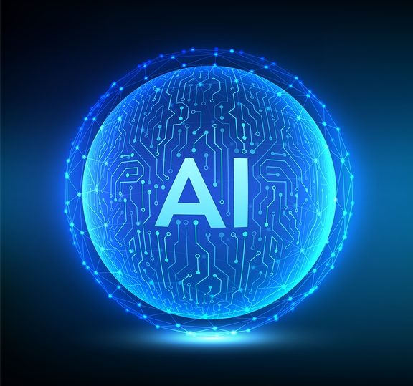 Generative AI is based on machine learning and deep learning algorithms. The first machine learning algorithm was developed by **Arthur Samuel** in 1952 for playing checkers. **(1950s)**

 The first historical example of generative AI was called **ELIZA**. It could also be considered an early version of chatbots. It was created in 1961 by Joseph Weizenbaum. **(1960-1970)**

 **The First AI Winter Separates Machine Learning and Artificial Intelligence.** **(1973-1979)**

In 1982, **John Hopfield** developed the Hopfield net which collected and retrieved memories more like the human brain does than previous systems did. **(1980s)**



**DEVELOPMENT OF GEN AI**

 The Face Recognition Grand Challenge, a promotion to improve facial recognition technology, was funded by the U.S. government and took place from 2004 and 2006. **(2000s)**

 On Oct 4, 2011, **Siri**, the first digital virtual assistant that was considered functional, came as a service with the iPhone 4S. The use of chatbots also increased significantly. **(2010s)**

 In November of 2022, **OpenAI** introduced **ChatGPT**, a generative AI combined with large language models. **(2020s)**



**EVOLUTION OF GEN AI (Roadmap)**

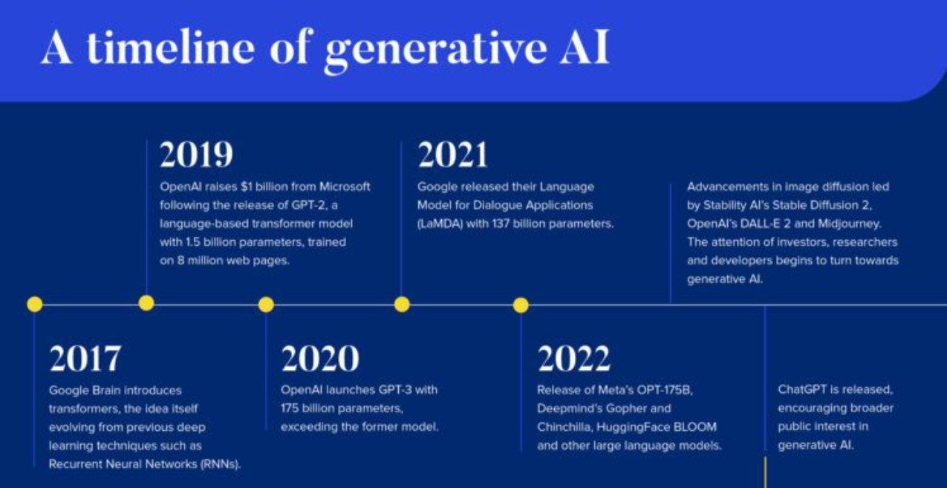



**APPLICATIONS OF GEN AI**

**HEALTHCARE AND PHARMACEUTICALS:**

Drug Discovery

Personalized Medicine

Predictive Imaging

**SOFTWARE DEVELOPMENT:**

Code Generation

Testing and Quality Assurance

**EDUCATION:**

Customized Learning Materials

Simulation and Training

**MANUFACTURING:**

Product Design

Supply Chain Optimization

**MEDIA AND ENTERTAINMENT:**

Game Development

Music and Art

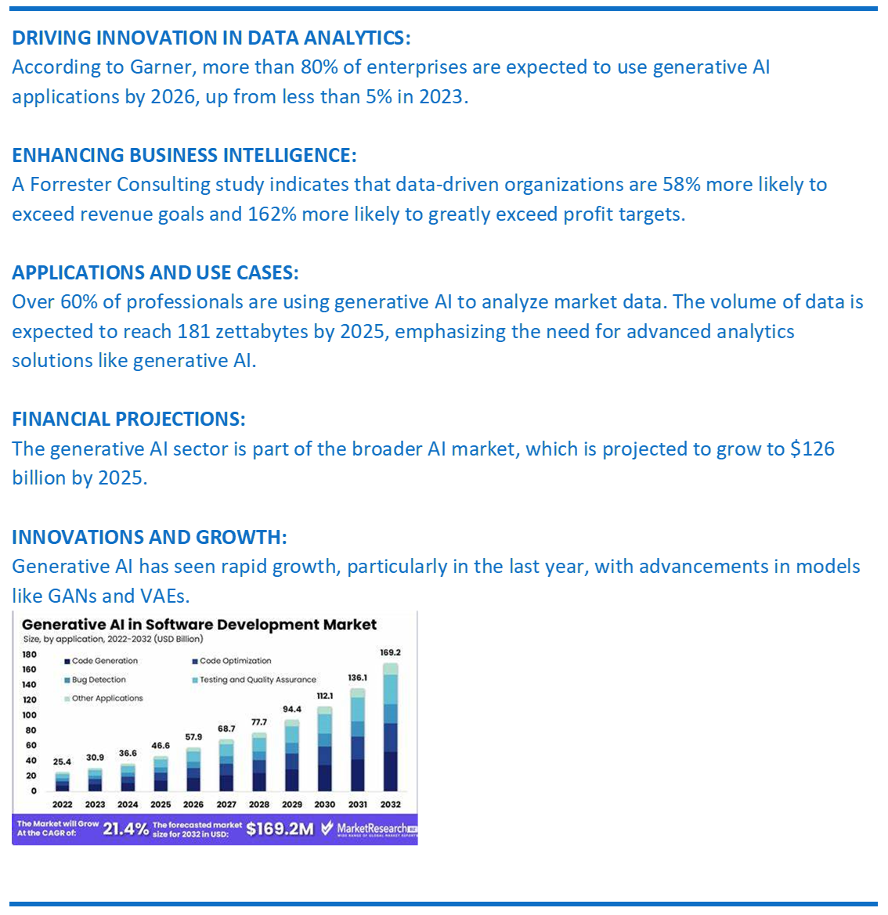

**BUSINESS ANALYSIS OF GEN AI**



ETHICAL RISKS:

Intellectual Property (IP) Theft

Misuse and Misinformation

Bias and Discrimination

TECHNICAL CHALLENGES:

Data Privacy

Security Vulnerabilities

Operational Challenges:

Strategic Roadmap

Talent Scarcity

Governance

**RISKS OF GEN AI**